Lab 05 – Worksheet

Name: Hatim Shabbir | Arsheel Abbas | ID: hs11045 | aa11163 | Section: T2

Note: Assumptions and logics should be explained separately in tasks after the task results.

Github:
https://github.com/arsheelabbas9/Lab05-Git-ArsheelAbbasANDHatimShabbir

Pre-Lab:
- Exercise 1: Synthesizability

Non-Synthesizable. The loop bound n is a variable. Synthesizers require constant loop bounds to generate fixed hardware.

- Exercise 2: Fix Non-Synthesizable Code

Fixed (Synthesizable): Real hardware uses physical clock signals (posedge clk) instead of delay tags (#10).

always @(posedge clk) begin
if (rst) q <= 1'b0;
else q <= d;
end

- Exercise 3: Inferred Hardware

always @(posedge clk) begin
if (en)
q <= d;
end

D Flip-Flop with Enable. posedge clk creates a flip-flop, while if (en) acts as a clock-enable line holding state when low.

Task 1
FSM:
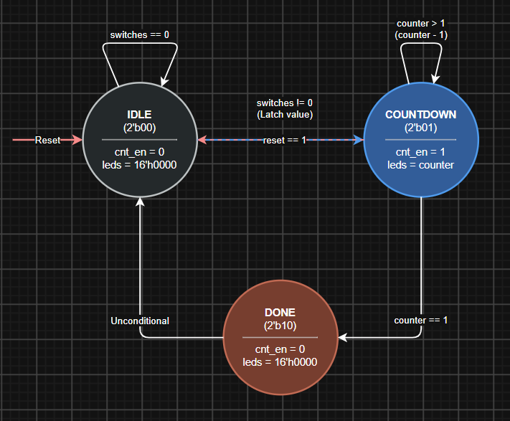

Comments

Task 2

Modules + Testbench:
Top Module:
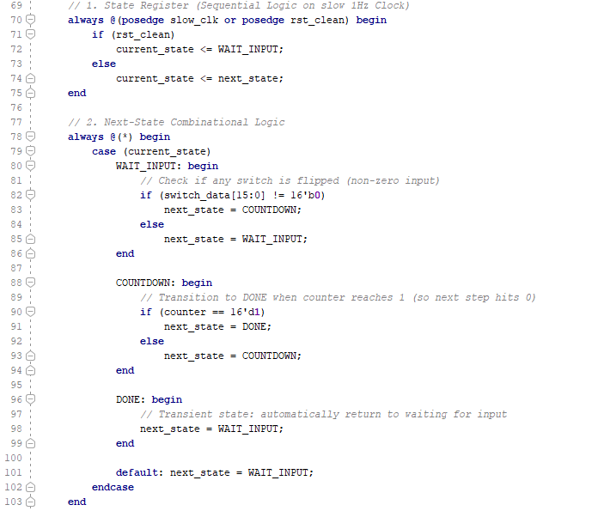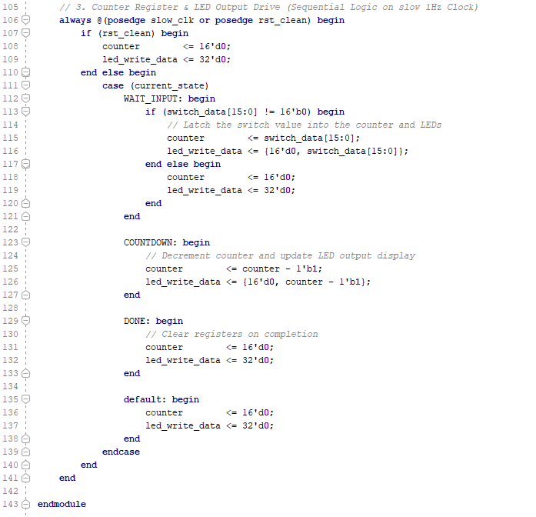

TestBench:
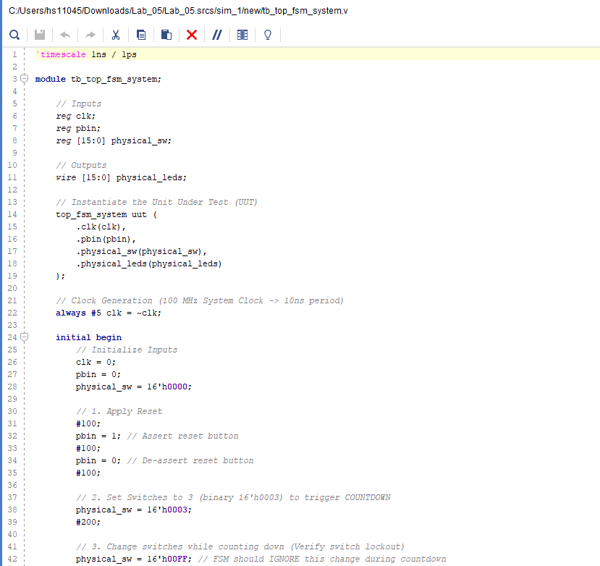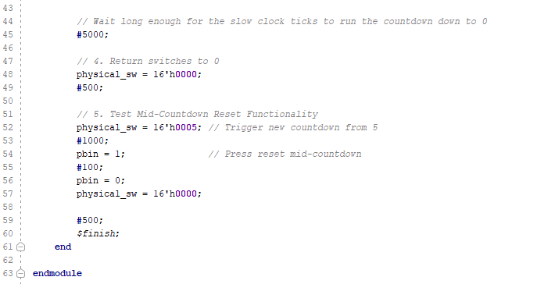

Results:
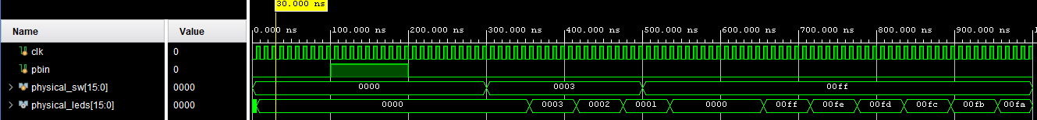

Task 3

XDC file
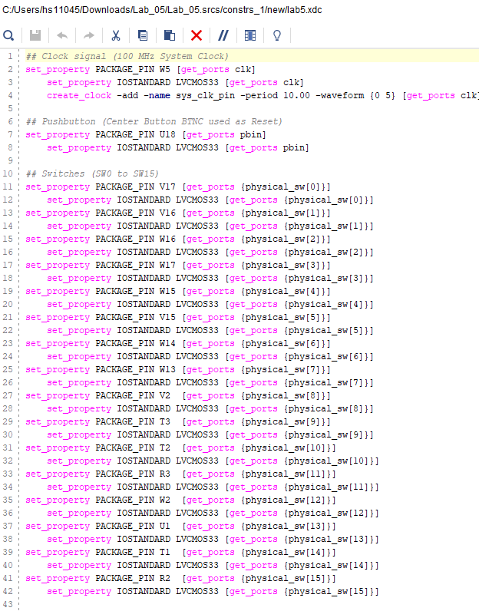

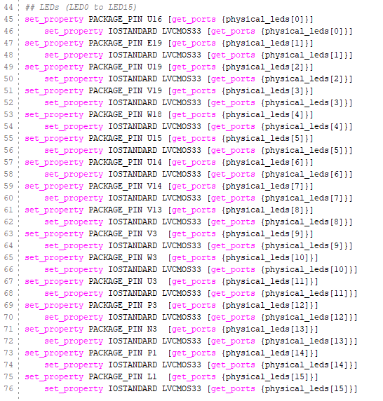

Timing Summary
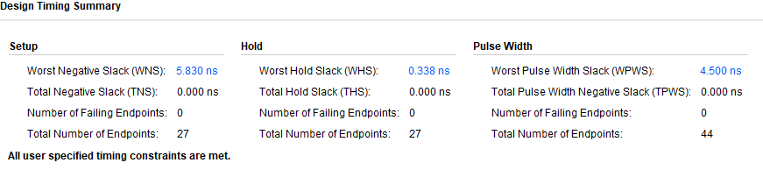

Interpretation:

Task 4

RTL Schematic:
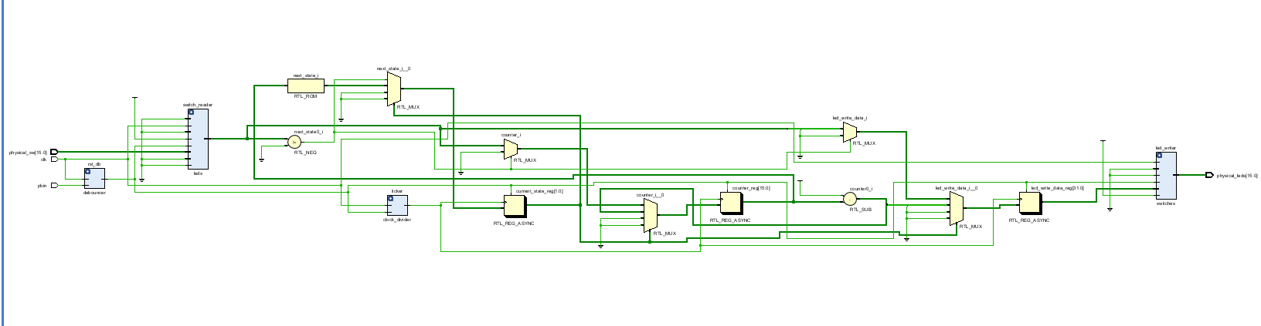

Results
VIDEO ON GITHUB!

Lab 05 – Designing FSM Using FPGA Switches and LEDs

Assessment Rubrics

Points Distribution
Task No. | LR2  Code | LR 5  Results | LR11  Design | AR7
Prelab |  | /15 |  | /10 & /10
Task 1 | - | - | /10 | /10 & /10
Task 2 | /15 | /10 |  | /10 & /10
Task 3 |  | /15 |  | /10 & /10
Task 4 |  | /15 |  | /10 & /10
Total Points | /80 |  |  | /20
CLO Mapped | CLO 1
For description of different levels of the mapped rubrics, please refer the provided Lab Evaluation Assessment Rubrics and Affective Domain Assessment Rubrics.
# | Assessment Elements | Level 1: Unsatisfactory  Points 0-1 | Level 2: Developing  Points 2 | Level 3:Good  Points 3 | Level 4:Exemplary  Points 4
LR2 | Program/Code/ Simulation Model/ Network Model | Program/code/simulation model/network model does not implement the required functionality and has several errors. The student is not able to utilize even the basic tools of the software. | Program/code/simulation model/network model has some errors and does not produce completely accurate results. Student has limited command on the basic tools of the software. | Program/code/simulation model/network model gives correct output but not efficiently implemented or implemented by computationally complex routine. | Program/code/simulation /network model is efficiently implemented and gives correct output. Student has full command on the basic tools of the software.
LR5 | Results & Plots | Figures/ graphs / tables are not developed or are poorly constructed with erroneous results. Titles, captions, units are not mentioned. Data is presented in an obscure manner. | Figures, graphs and tables are drawn but contain errors. Titles, captions, units are not accurate. Data presentation is not too clear. | All figures, graphs, tables are correctly drawn but contain minor errors or some of the details are missing. | Figures / graphs / tables are correctly drawn and appropriate titles/captions and proper units are mentioned. Data presentation is systematic.
AR9 | Report | All the in-lab tasks are not included in report and / or the report is submitted too late. | Most of the tasks are included in report but are not well explained. All the necessary figures / plots are not included. Report is submitted after due date. | Good summary of most the in-lab tasks is included in report. The work is supported by figures and plots with explanations. The report is submitted timely. | Detailed summary of the in-lab tasks is provided. All tasks are included and explained well. Data is presented clearly including all the necessary figures, plots and tables.

